PABSON SHIVRAJ
1st terminal Examination 2081
Class: 5 Time: 2Hours. Full Marks: 50
Subject: Maths
Attempt all question
1. a) What is the complementary angle of 65$°$ ? 1
b) Draw a pair of parallel line ,name it . 1
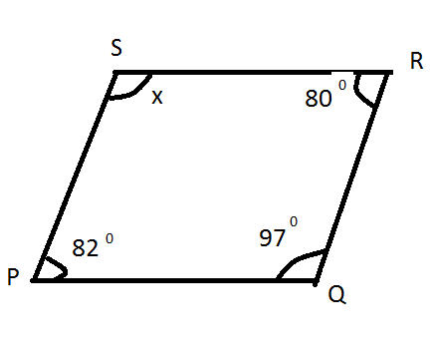
c) Find the value of 'x' ? 3

2a) Draw a geometric shape of cuboid ? 2
b) Count the face , vertices and edges of cuboid ? 3
3. The4 digits 4,5,0 and 9
a) From greatest number of given digits . 1
b) From smallest number of given digits. 1
c) Find the sum and difference of greatest and smallest number. 3
4. The height of Mt Everest is 8848m
a) Round of nearest thousand (1000) . 1
b) Write in Roman . 2
c) Write in Devanagari number name. 2
5a) Which is the Even prime number. 1
b) Find the set of factors of 36 2
c) Factorize 75 into prime factors. 2
6a) Simplify : 60-75$÷$5 +11× 5 (2.5)
b) Ram had Rs 100 in his pocket . He spend Rs 30 His mother gave him Rs 5 .How much is left with Ram ? (2.5)
7a) Identify the fraction $\frac{7}{9}$ and $\frac{9}{7}$ as like or unlike 1
b) Convert 5 $\frac{5}{7}$ into improper fraction. 1
c) Write the three equivalent fraction of $\frac{4}{5}$ 3
8. a) Add: $\frac{4}{10}+ \frac{3}{10}$
b) Subtract : $\frac{2}{3}$-$\frac{1}{3}$ 3
c) Simplify : $\frac{3}{8}+\frac{5}{8}$ - $\frac{1}{8}$ 2
9.a) Define a straight angle . 1
b) A protractor has marked from 0$°$ to ........ 1
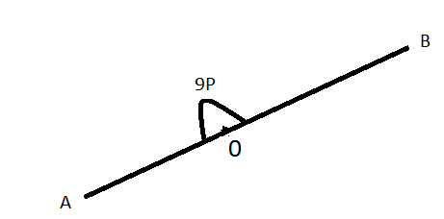
c) Find the value of 'P' in given straight line . 2

10. a) Write $\frac{202}{10}$ as a decimal . 1
b) Subtract : (5.8-2.451) 2
c) Express $\frac{30}{42}$ in the simplest form . 2
THE END

